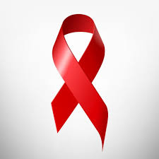VACSI is fighting to be the leading global effort to end AIDS as a public health threat by 2030 as part of the Sustainable Development Goals.

Since the first cases of HIV were reported more than 35 years ago, 78 million people have become infected with HIV and 35 million have died from AIDS-related illnesses. Since it started operations in 2016, VACSI has fostered and inspired global, regional, national and local leadership, innovation and partnership to ultimately consign HIV to history.

VACSI is a problem-solver. It places people living with HIV and people affected by the virus at the decision-making table and at the centre of designing, delivering and monitoring the AIDS response. It charts paths for countries and communities to get on the Fast-Track to ending AIDS and is a bold advocate for addressing the legal and policy barriers to the AIDS response.

VACSI provides the strategic direction, advocacy, coordination and technical support needed to catalyse and connect leadership from governments, the private sector and communities to deliver life-saving HIV services.

We pursue to generate strategic information and analysis that increases the understanding of the state of the AIDS epidemic and progress made at the local, national, regional and global levels. We strive to construct an extensive data collection on HIV epidemiology, programme coverage and finance and publish the most authoritative and up-to-date information on the HIV epidemic—vital for an effective AIDS response.

VACSI is a model for UNAIDS reform which is a cosponsored Joint Programme in the United Nations system. It draws on the experience and expertise of 11 United Nations system Cosponsors and is the only United Nations entity with civil society represented on its governing body.

VACSI has helped to position, shape and scale up the response to HIV, encouraging dialogue and bringing in communities that have been left out of decision-making. Without VACSI, the human rights of people living with HIV would have been held back and the voice of civil society would be heard far less often.

We have a transformed policy. VACSI works hard at public policy on HIV at the global, regional and national levels.